Lab name：**Operational Amplifier** Student ID： B11102112 Name: Chiajui Lee

# Purpose

The operational amplifier (Op-Amp) is a differential amplifier with high gain, high input impedance and low output impedance. It is an indispensable and important component in modern electronic circuits. The application range of operational amplifiers is very wide, including amplification, filtering, oscillation, comparison, calculation, etc.

The main experimental purposes of operational amplifiers are as follows:

* We can understand the basic principles and characteristics of operational amplifiers, including gain, input impedance, output impedance, common-mode rejection ratio, etc.
* Master the basic application circuits of operational amplifiers, including inverting amplifiers and non-inverting amplifiers.

# Steps

1. Use an operational amplifier (OPA) and resistors to form the circuit required by the question.
2. The power supply inputs +10V voltage to the 𝑉+ terminal of the OPA and -10V voltage to the 𝑉−terminal and uses the waveform generator. The amplitude of the sin waveform is 1 𝑉𝑝-𝑝.
3. Measure the output using an oscilloscope

# Data

1. Inverting amplifier
   1. Input = 1 𝑉𝑝−𝑝, 1KHz, Sin wave

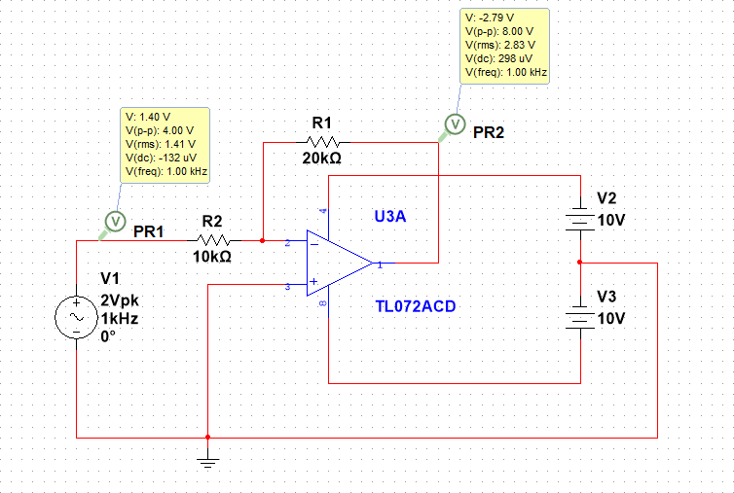

* 1. Output waveform

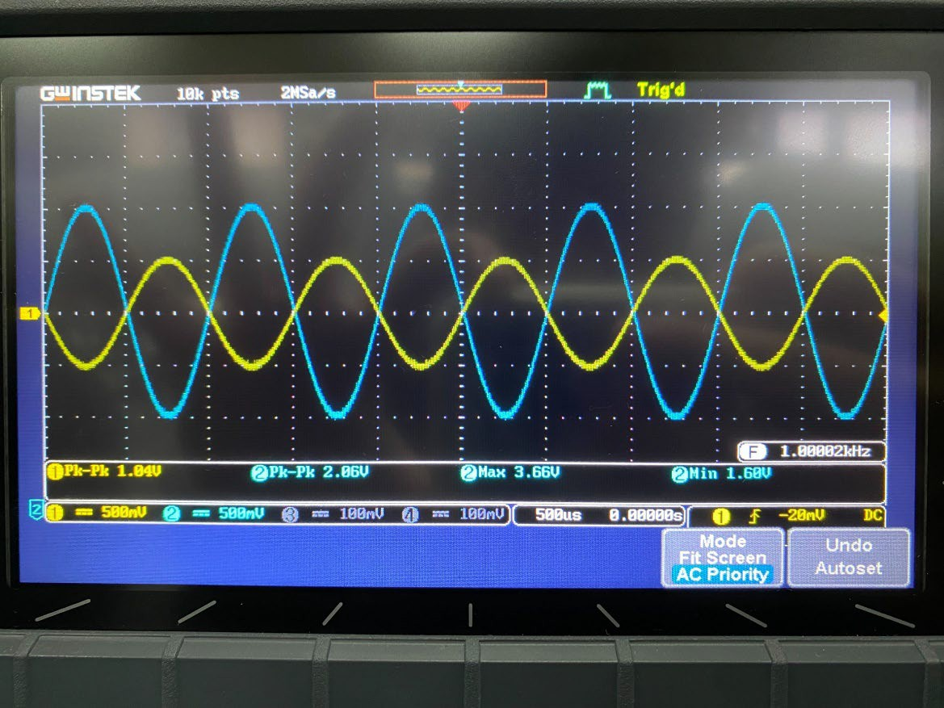

* 1. Voltage Gain

|  |  |  |
| --- | --- | --- |
|  | Measured Value | Theoretical Value |
| Av | 1.98 | 2 |

1. Non-inverting amplifier
2. Input = 1 𝑉𝑉𝑝𝑝−𝑝𝑝, 1KHz,Sin wave

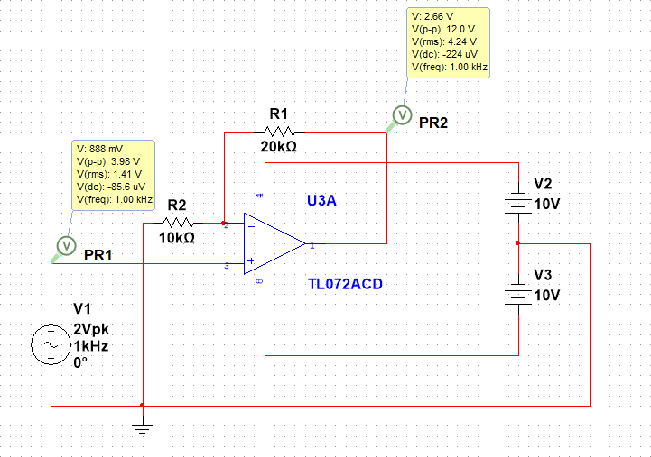

1. Output Waveform

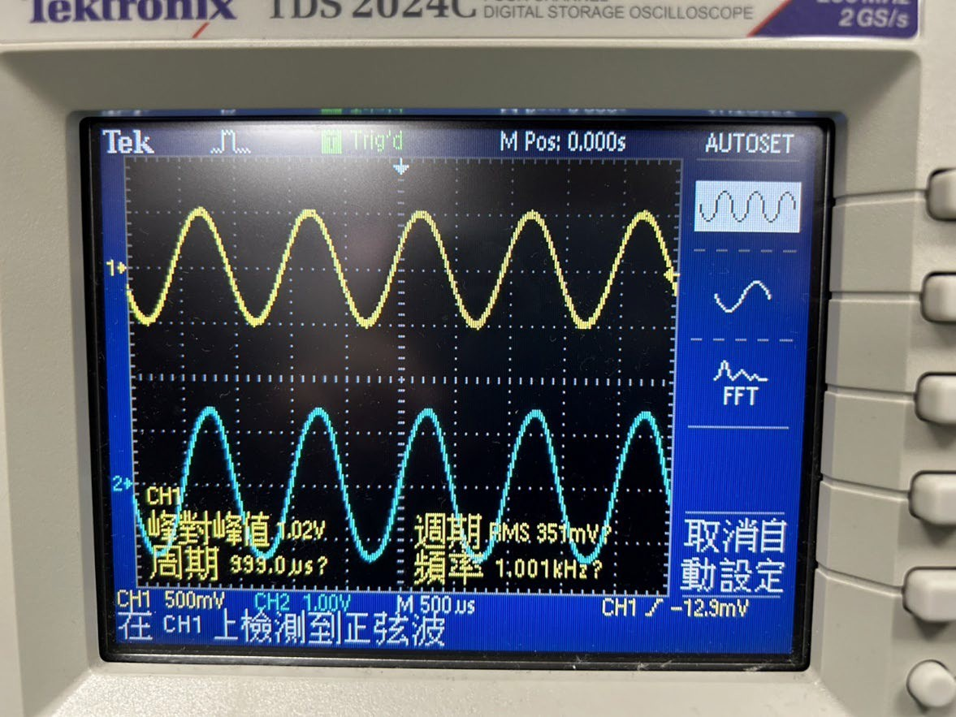

1. Voltage Gain

|  |  |  |
| --- | --- | --- |
|  | Measured Value | Theoretical Value |
| Av | 2.78 | 3 |

1. Non-inverting amplifier (R2 = 330KΩ)
2. Input = 1 𝑉𝑉𝑝𝑝−𝑝𝑝, 1KHz,Sin wave

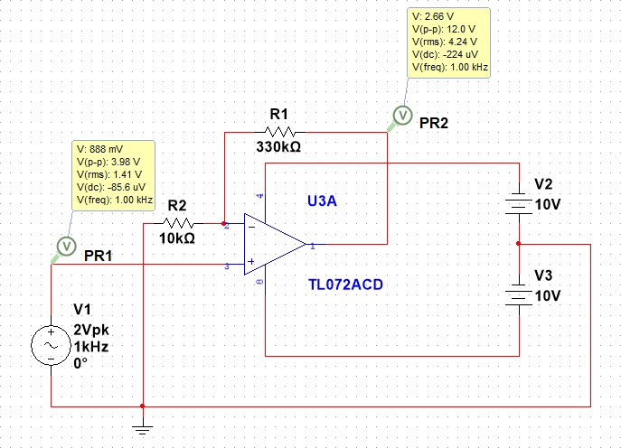

1. Output Waveform

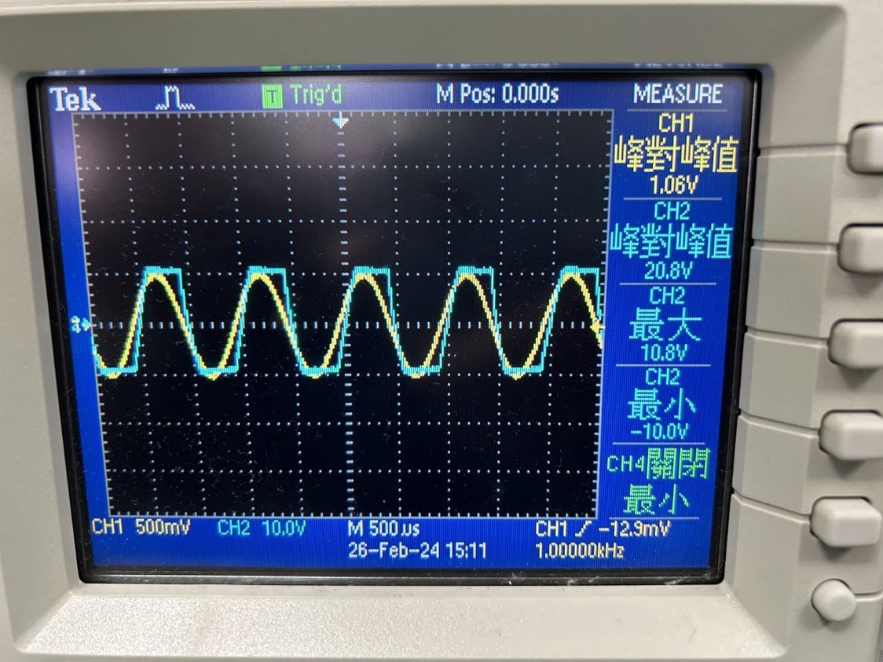

1. Voltage Gain

|  |  |  |
| --- | --- | --- |
|  | Measured Value | Theoretical Value |
| Av | 19.5 | 30 |

1. Non-inverting amplifier(let voltage gain = 0.5)
2. Design

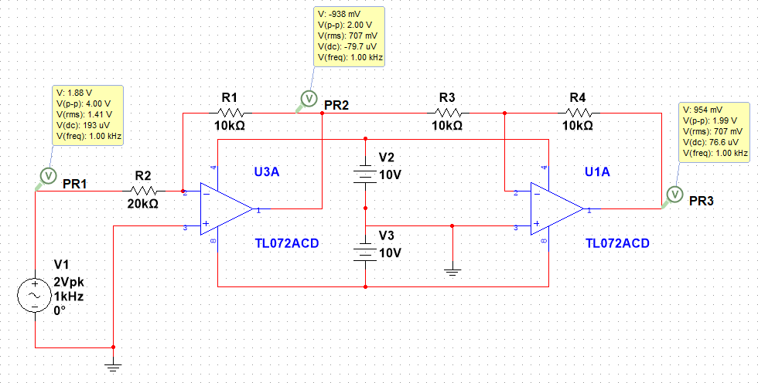

1. Output waveform

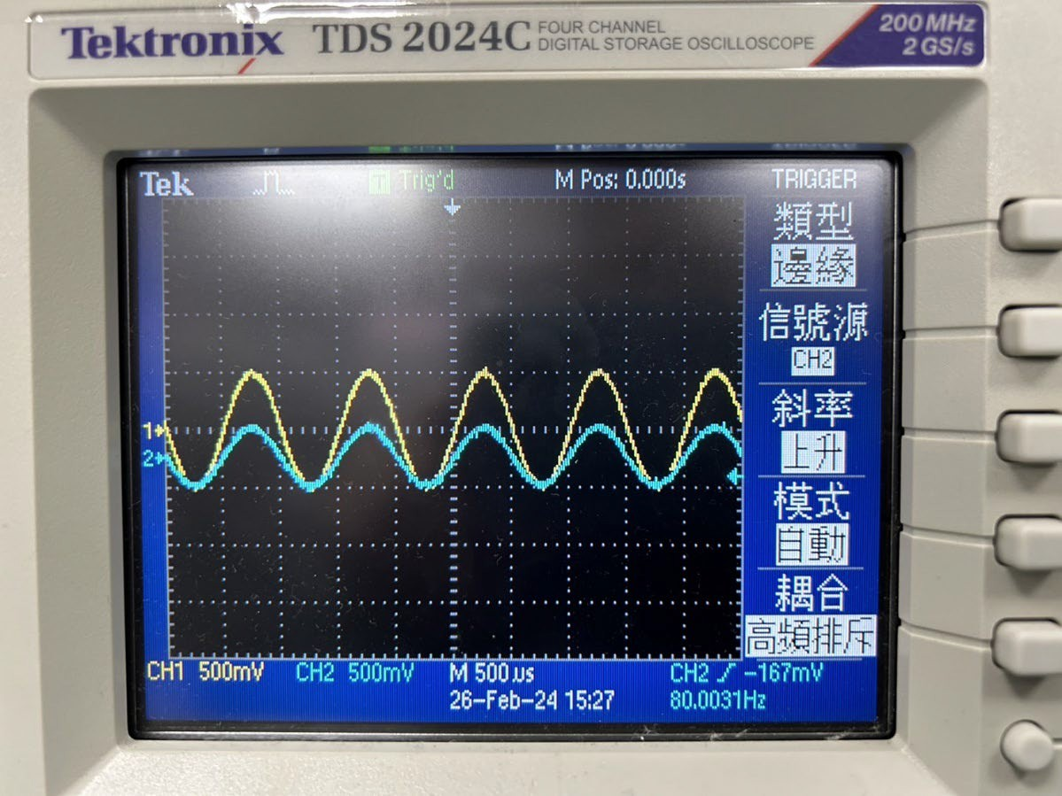

1. Voltage Gain

|  |  |  |
| --- | --- | --- |
|  | Measured Value | Theoretical Value |
| Av | 0.47 | 0.5 |

# Questions and Discussion

This experiment allows us to learn how to use an operational amplifier as an amplifier and discover some problems that only experiments can cause.

1. Measuring OPA Why is the maximum value measured by an oscilloscope not equal to the minimum absolute value?
   * DC offset: There may be multiple transistors in the operational amplifier with small parameter mismatches or changes in the transistor threshold voltage due to temperature changes, which are all factors that cause DC offset.
   * Signal distortion: Nonlinear distortion or distortion of the output waveform may also cause the maximum and minimum values ​​measured by the oscilloscope to be inconsistent.
2. Why OPA's measurement results deviate from the theoretical values?
   * Difference between ideal model and real model: In the ideal model, infinite input impedance and zero output impedance are assumed. However, in actual circuits, transistors and resistors have non-idealities, which causes the measured results to differ from the actual values.
   * Output Load Effect: Connecting a load resistor or other circuits will affect the output voltage due to the load.

# Reflections

The purpose of this experiment was to investigate the basic characteristics and applications of operational amplifiers. An operational amplifier is a common electronic component that can be used to achieve various linear and nonlinear circuit functions, such as amplification, subtraction, integration, differentiation, and comparison.

However, during the experiment, we encountered a problem where the operational amplifier's output failed to function properly. After checking, we found that the issue was caused by incorrectly connecting the power supply due to my confusion between the main and auxiliary ports of the power supply unit. After correcting the power supply wiring, the operational amplifier resumed normal operation.

This experiment also taught me an important concept: DC offset. DC offset can affect the accuracy and sensitivity of the operational amplifier, so in practical applications, it is necessary to calibrate or compensate for DC offset. During the experiment, we used an oscilloscope to observe the output waveform of the operational amplifier and found that, due to DC offset, the measured maximum and minimum values were not always equal.

Although this experiment involved a familiar component, it allowed me to experience the various characteristics and applications of operational amplifiers, as well as uncover some of their limitations and issues. This has greatly helped us gain a deeper understanding of the principles and design of operational amplifiers.